Great job completing the Random Forest Classification algorithm! Here are some steps you can take to further enhance your analysis and derive more insights:

1. Model Evaluation and Tuning:

Cross-Validation: Perform cross-validation to ensure the robustness of your model.

Hyperparameter Tuning: Use techniques like Grid Search or Random Search to find the optimal hyperparameters for your Random Forest model.

2. Feature Engineering:

Interaction Features: Create new features by interacting existing ones to capture more complex relationships.

Feature Selection: Identify and select the most important features that contribute to the model's performance.

3. Model Comparison:

Try Other Models: Compare the performance of the Random Forest model with other algorithms like Gradient Boosting, XGBoost, or even simpler models like Logistic Regression.

Ensemble Methods: Combine multiple models to improve the overall prediction accuracy.

4. Performance Metrics:

Additional Metrics: Evaluate your model using additional metrics like Precision, Recall, F1-Score, and ROC-AUC to get a better understanding of its performance.

5. Visualization:

SHAP Values: Use SHAP (SHapley Additive exPlanations) values to understand the contribution of each feature to the predictions.

Partial Dependence Plots: Visualize the relationship between the features and the predicted outcome.

6. Documentation and Reporting:

Document Your Process: Keep a detailed record of your analysis, including the steps taken, the rationale behind decisions, and the results obtained.

Create a Report: Summarize your findings in a report or presentation to share with stakeholders or colleagues.

7. Deployment:

Model Deployment: If your model performs well, consider deploying it into a production environment to make real-time predictions.

Monitor Model Performance: Continuously monitor the performance of your deployed model and update it as needed based on new data.

Example: Hyperparameter Tuning with Grid Search

Here's an example of how you might perform hyperparameter tuning using Grid Search:

python

from sklearn.model_selection import GridSearchCV

# Define the parameter grid

param_grid = {

'n_estimators': [100, 200, 300],

'max_depth': [None, 10, 20, 30],

'min_samples_split': [2, 5, 10],

'min_samples_leaf': [1, 2, 4]

}

# Initialize the GridSearchCV object

grid_search = GridSearchCV(estimator=RandomForestClassifier(random_state=42),

param_grid=param_grid,

cv=5, n_jobs=-1, verbose=2)

# Fit the grid search to the data

grid_search.fit(X_train, y_train)

# Get the best parameters and best score

best_params = grid_search.best_params_

best_score = grid_search.best_score_

print("Best Parameters:", best_params)

print("Best Score:", best_score)

By taking these steps, you can further refine your model, gain deeper insights, and potentially improve its performance. If you need help with any specific step or have additional questions, feel free to ask!

1. Model Evaluation and Tuning:

**Cross-Validation:** Perform cross-validation to ensure the robustness of your model.

|  |
| --- |
| from sklearn.model_selection import cross_val_score  # Perform a 5-fold cross-validation  cv_scores = cross_val_score(model, X, y, cv=5, scoring='accuracy')  # Print cross-validation scores  print("Cross-Validation Scores:", cv_scores)  print("Mean Cross-Validation Score:", cv_scores.mean()) |

[Output]

Cross-Validation Scores: [0.8491 0.7883 0.7327 0.538 0.777 ]

Mean Cross-Validation Score: 0.73702

Determining whether a model is accurate enough for production use involves more than just looking at its accuracy score. Here are some key factors to consider:

**1. Evaluation Metrics:**

* **Accuracy**: You've already calculated an average accuracy of 73.7%. Depending on the application, this might be sufficient, but other metrics like Precision, Recall, F1-Score, and ROC-AUC might also be important.
* **Confusion Matrix**: Analyze the confusion matrix to see how well the model distinguishes between different classes.

**2. Business Impact:**

* **Cost of Errors**: Consider the cost of false positives and false negatives. For example, if predicting booking_complete incorrectly has significant business implications, you may need a higher accuracy or better performance in other metrics.
* **Business Requirements**: Ensure the model meets the specific accuracy and performance requirements set by your business or stakeholders.

**3. Model Robustness:**

* **Cross-Validation Variance**: The cross-validation scores show some variability (0.8491 to 0.538). A high variance can indicate that the model may not generalize well to unseen data. Ensuring the model is robust across different subsets of data is crucial.
* **Overfitting/Underfitting**: Check if the model is overfitting (performing well on training data but poorly on test data) or underfitting (not capturing the underlying patterns in the data).

**4. Data Quality and Quantity:**

* **Data Quality**: Ensure the data used to train the model is of high quality, with minimal noise and missing values.
* **Data Quantity**: Having a sufficient amount of data is essential for training a robust model. If the dataset is small, the model may not capture all the necessary patterns.

**5. Feature Importance:**

* **Feature Analysis**: Analyze the importance of different features to ensure they make sense and contribute meaningfully to the predictions.

**6. Performance in Real-World Scenarios:**

* **Real-World Testing**: Before deploying, test the model in real-world scenarios to see how it performs on new, unseen data.
* **Monitoring and Maintenance**: After deployment, continuously monitor the model's performance and update it as needed based on new data.

**Next Steps:**

1. **Evaluate Additional Metrics**: Calculate Precision, Recall, F1-Score, and ROC-AUC to get a comprehensive view of the model's performance.
2. **Hyperparameter Tuning**: Perform hyperparameter tuning to optimize the model further.
3. **Real-World Testing**: Test the model with real-world data to ensure it meets your business requirements.
4. **Monitor and Update**: Implement monitoring to track the model's performance over time and update it as necessary.

By considering these factors, you can better assess whether your model is ready for production. If you need more detailed guidance on any of these steps, feel free to ask!

**Evaluate Additional Metrics**: Calculate Precision

# prompt: Calculate Precision

# Assuming 'model' and 'X_test', 'y_test' from the provided code are available

from sklearn.metrics import precision_score

# Make predictions on the test set

y_pred = model.predict(X_test)

# Calculate precision

precision = precision_score(y_test, y_pred)

print(f"Precision: {precision}")

[Output]]

Precision: 0.5290858725761773

mproving the precision of your model involves several strategies that can help reduce the number of false positives. Here are some key approaches to consider:

**1. Feature Engineering:**

* **Create New Features**: Generate new features that might capture additional information from the data.
* **Select Relevant Features**: Remove irrelevant or less important features that may be introducing noise into the model.

**2. Hyperparameter Tuning:**

* **Optimize Hyperparameters**: Use techniques like Grid Search or Random Search to find the optimal hyperparameters for the model, such as the number of trees (n_estimators), maximum depth (max_depth), and minimum samples per leaf (min_samples_leaf).

Python

|  |
| --- |
| from sklearn.model_selection import GridSearchCV  param_grid = {  'n_estimators': [100, 200, 300],  'max_depth': [None, 10, 20, 30],  'min_samples_split': [2, 5, 10],  'min_samples_leaf': [1, 2, 4]  }  grid_search = GridSearchCV(estimator=RandomForestClassifier(random_state=42), param_grid=param_grid, cv=5, scoring='precision', n_jobs=-1, verbose=2)  grid_search.fit(X_train, y_train)  best_params = grid_search.best_params_  print("Best Parameters:", best_params) |

**3. Balance the Dataset:**

* **Handle Class Imbalance**: If your dataset is imbalanced, consider techniques like oversampling the minority class, undersampling the majority class, or using synthetic data generation methods like SMOTE (Synthetic Minority Over-sampling Technique).

Python

|  |
| --- |
| from imblearn.over_sampling import SMOTE  smote = SMOTE(random_state=42)  X_resampled, y_resampled = smote.fit_resample(X_train, y_train) |

**4. Threshold Adjustment:**

* **Adjust Decision Threshold**: Modify the probability threshold for classifying a positive instance. By default, it's set to 0.5, but you can increase it to reduce false positives.

Python

|  |
| --- |
| # Predict probabilities  y_prob = model.predict_proba(X_test)[:, 1]  # Adjust threshold  threshold = 0.6  y_pred_threshold = (y_prob >= threshold).astype(int) |

**5. Model Ensemble:**

* **Combine Multiple Models**: Use ensemble methods to combine predictions from multiple models to improve overall performance.

Python

|  |
| --- |
| from sklearn.ensemble import VotingClassifier  model1 = RandomForestClassifier(n_estimators=100, random_state=42)  model2 = GradientBoostingClassifier(n_estimators=100, random_state=42)  ensemble_model = VotingClassifier(estimators=[('rf', model1), ('gb', model2)], voting='soft')  ensemble_model.fit(X_train, y_train) |

**6. Feature Importance Analysis:**

* **Focus on Important Features**: Analyze and give more weight to the most important features identified by the Random Forest model.

Python

|  |
| --- |
| importances = model.feature_importances_  important_features = [feature for feature, importance in zip(X.columns, importances) if importance > 0.1] |

**7. Cross-Validation:**

* **Use Cross-Validation**: Perform cross-validation to ensure the model generalizes well to unseen data.

Python

|  |
| --- |
| cv_scores = cross_val_score(model, X, y, cv=5, scoring='precision')  print("Cross-Validation Precision Scores:", cv_scores)  print("Mean Cross-Validation Precision:", cv_scores.mean()) |

**Summary:**

By implementing these strategies, you can work on improving your model's precision and make it more suitable for your specific application.

Let's optimize your Random Forest model using Grid Search to find the best hyperparameters. Grid Search systematically works through multiple combinations of parameter values to find the best combination based on cross-validation performance.

### Steps for Hyperparameter Tuning with Grid Search:

1. **Import Required Libraries**:

|  |
| --- |
| 1. import pandas as pd 2. from sklearn.model_selection import train_test_split, GridSearchCV 3. from sklearn.ensemble import RandomForestClassifier |
|  |

**Load and Preprocess Your Dataset**: (Assuming the dataset is already preprocessed as shown in previous examples.) – done already

**Define Features and Target**:

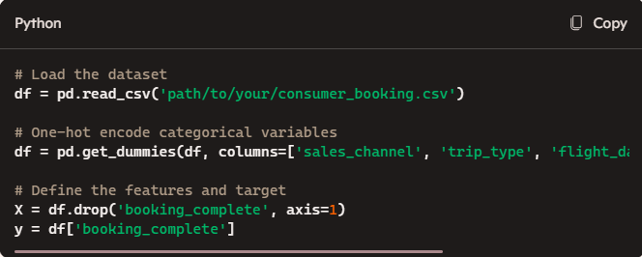

**Split the Data into Training and Testing Sets**:

X_train, X_test, y_train, y_test = train_test_split(X, y, test_size=0.2, random_state=42)

**Define the Parameter Grid**:

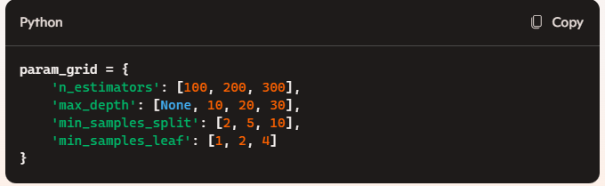

**Initialize the Grid Search**:

* Use GridSearchCV to search for the best hyperparameters.

|  |
| --- |
| grid_search = GridSearchCV(estimator=RandomForestClassifier(random_state=42),  param_grid=param_grid,  cv=5, # 5-fold cross-validation  scoring='precision', # Optimize for precision  n_jobs=-1, # Use all available cores  verbose=2) |

**Fit the Grid Search to the Data**:

* Train the model with different parameter combinations.

grid_search.fit(X_train, y_train)

**Get the Best Parameters and Score**:

* Retrieve the optimal parameters and the best cross-validation score.

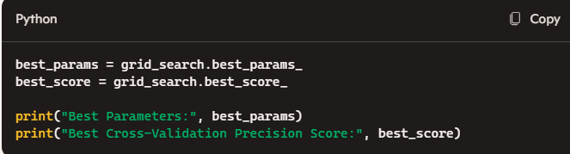

Running this code will help you find the best hyperparameters for your Random Forest model, optimizing it for better precision.